**Report**

**One days’ Workshop on How to plan for Startups in Agriculture organized on 07-03-2025**

Institutions Innovation Council in collaboration with Women Development Cell, Government Post Graduate College Ambala Cantt, organized a Workshop on How to plan for Startups in Agriculture organized on 07-03-2025 to celebrate international women’s day. The workshop Women's Empowerment through Agriculture: Breaking down Barriers" aims to equip women with knowledge and skills to overcome challenges in agriculture and enhance their economic independence. This workshop foster a supportive environment for women to share experiences, build networks, and advocate for their rights in the agricultural sector. The workshop was conducted under the mentorship of Dr. Shagun Ahuja Convener-IIC, Dr. Alka convener of women cell, and Dr. Poonam Dhiman Coordinator of the event. The workshop received overwhelming response from the participants. Worthy principal Dr. Desraj Bajwa congratulated the organizing members for successfully executed the exhibition.



Dr. Des Raj Bajwa

Principal

**Brochure**

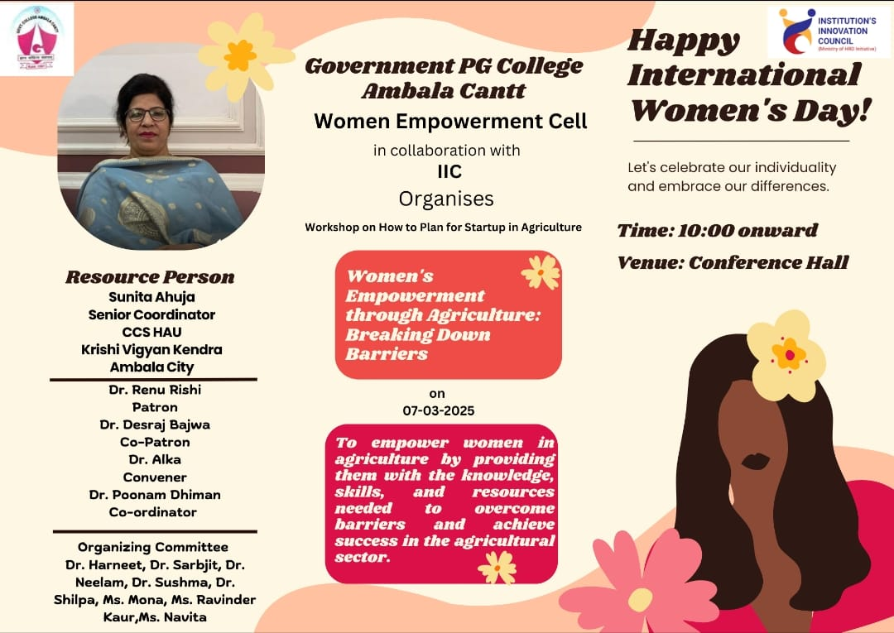



Dr. Des Raj Bajwa

Principal

**Report**

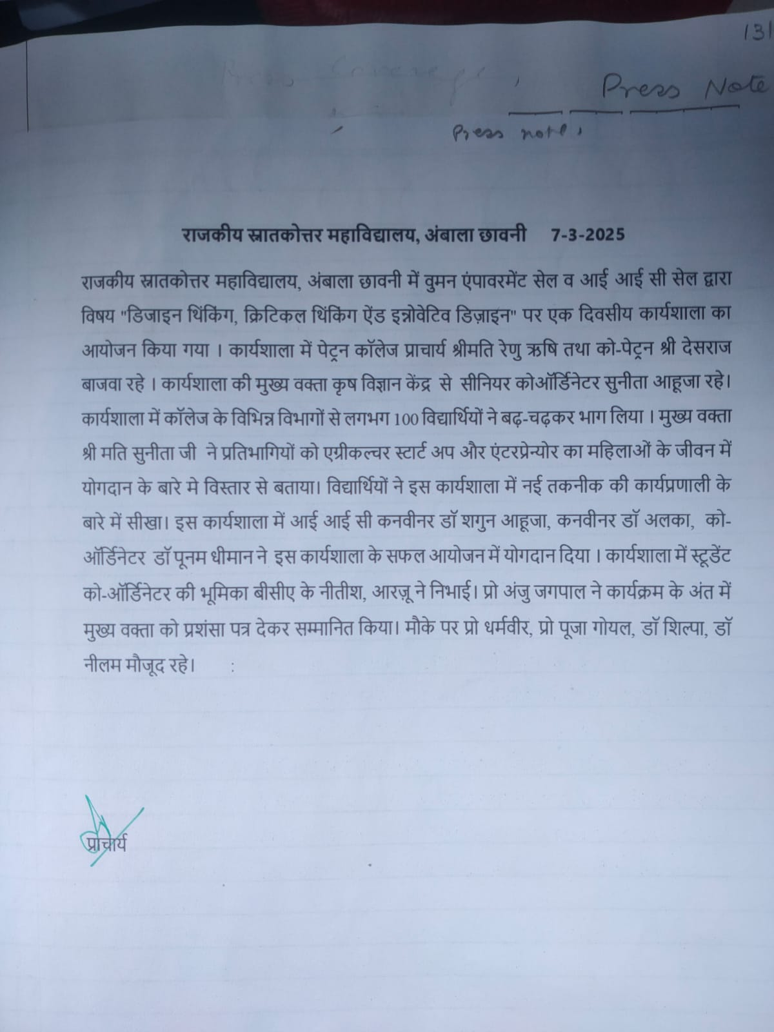

**Photographs**

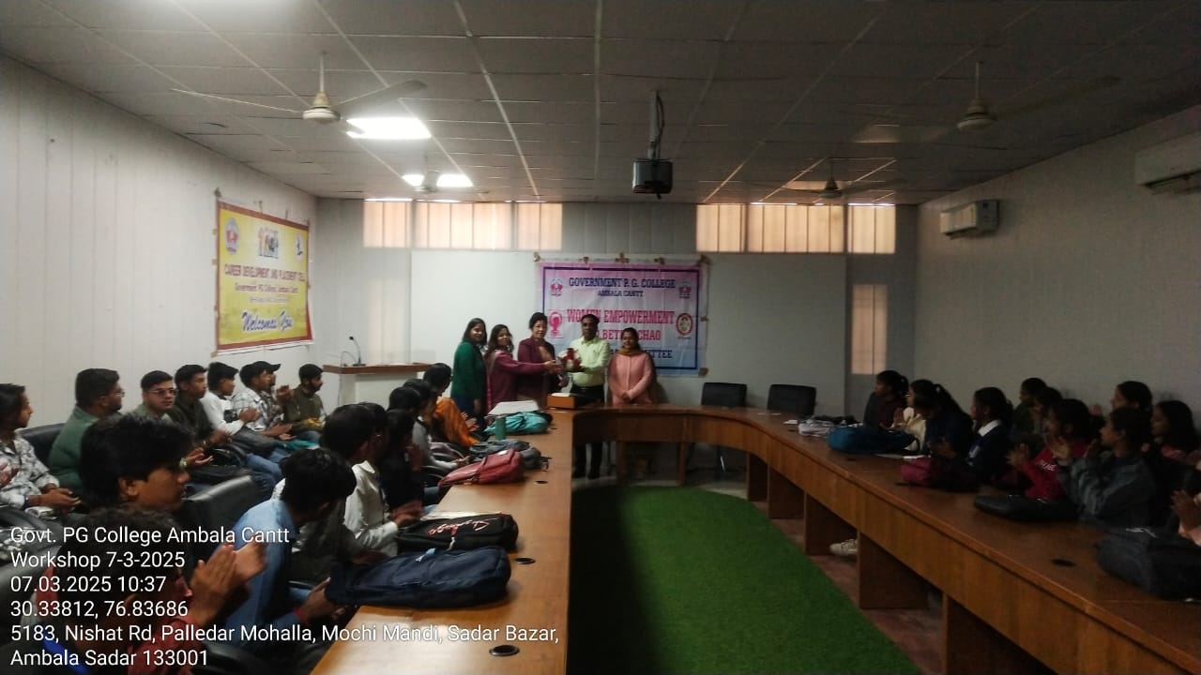

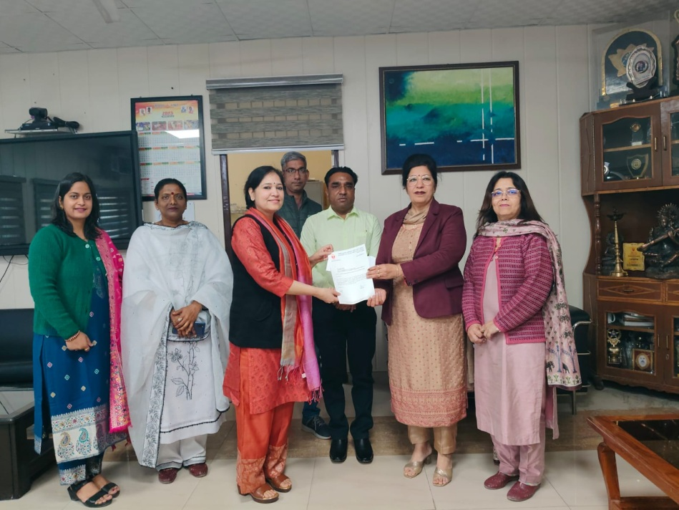

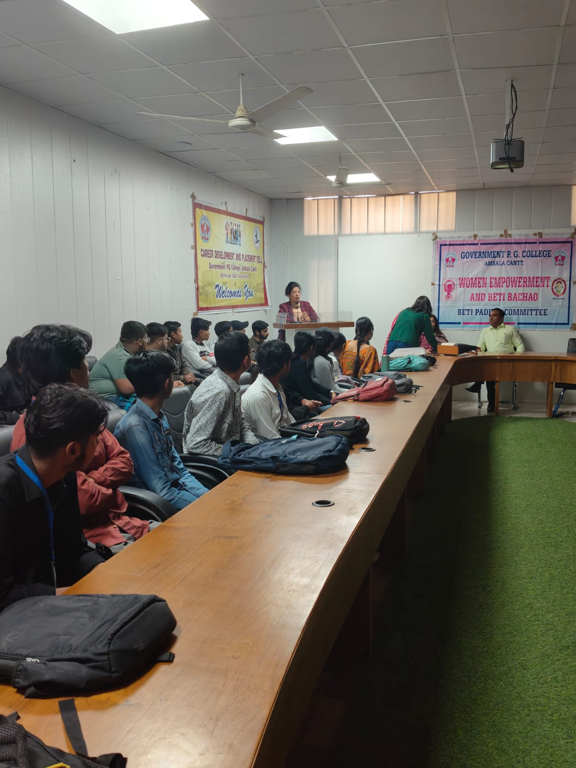



Dr. Des Raj Bajwa

Principal

**Attendance**

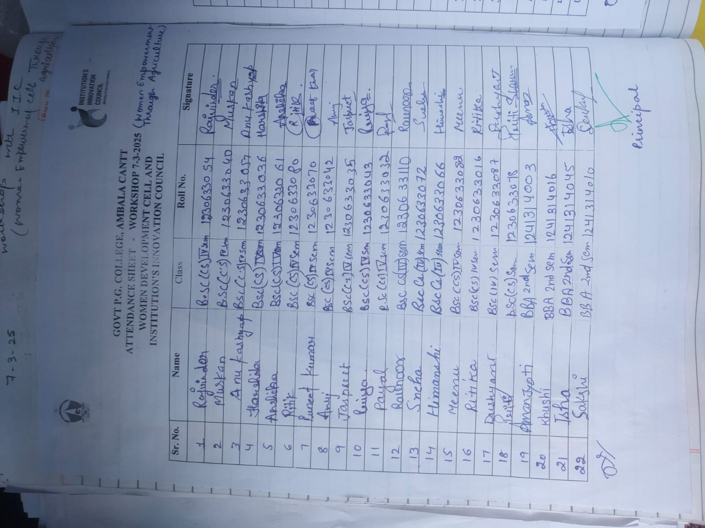

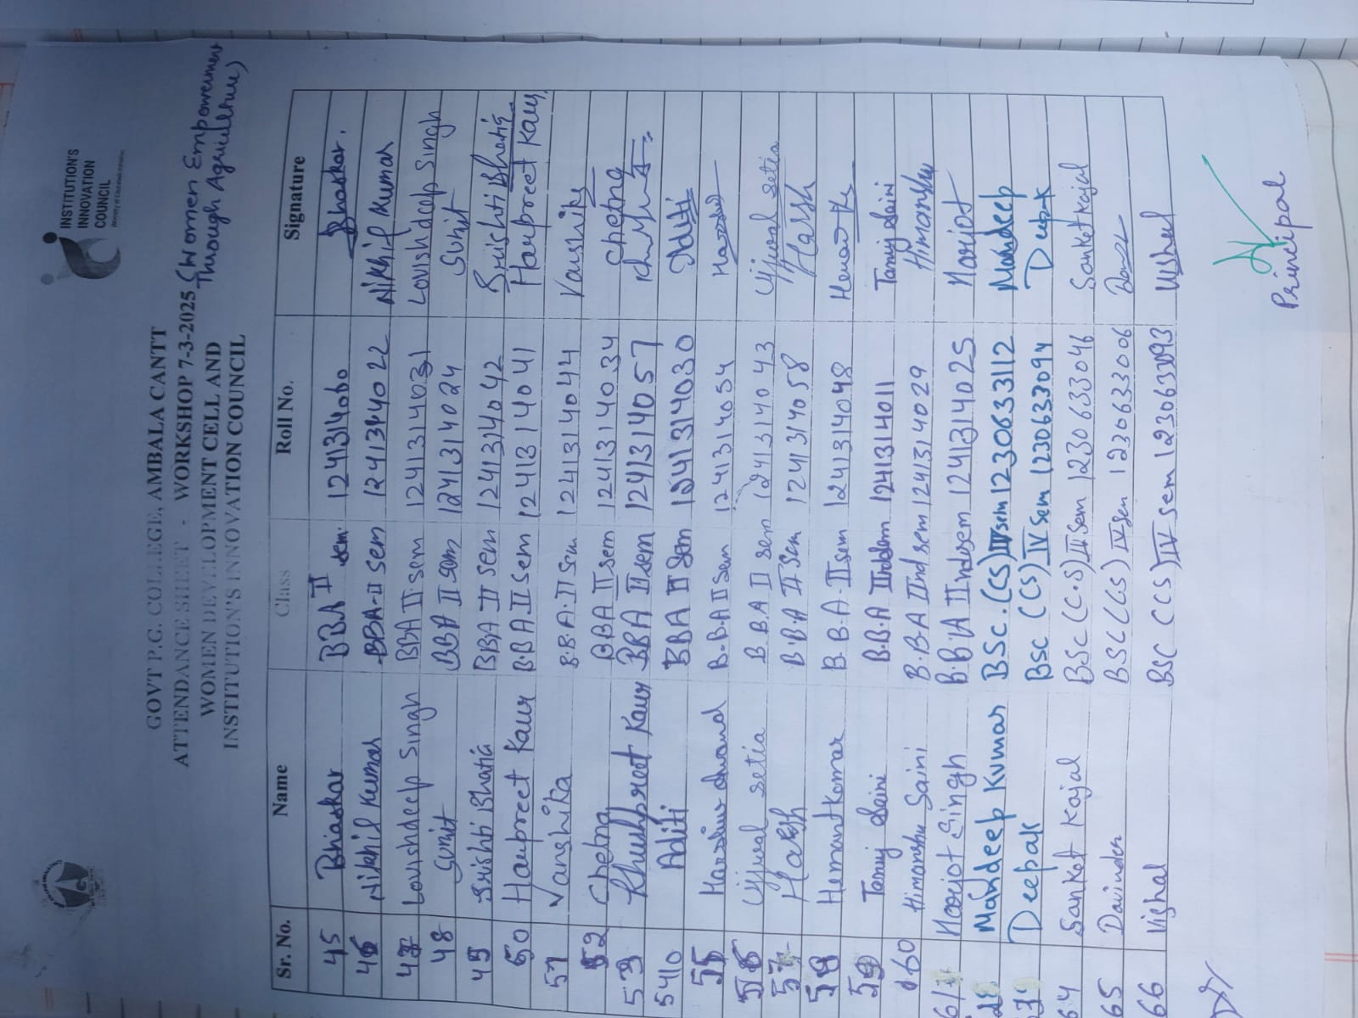



Dr. Des Raj Bajwa

Principal

**Invitation letter**

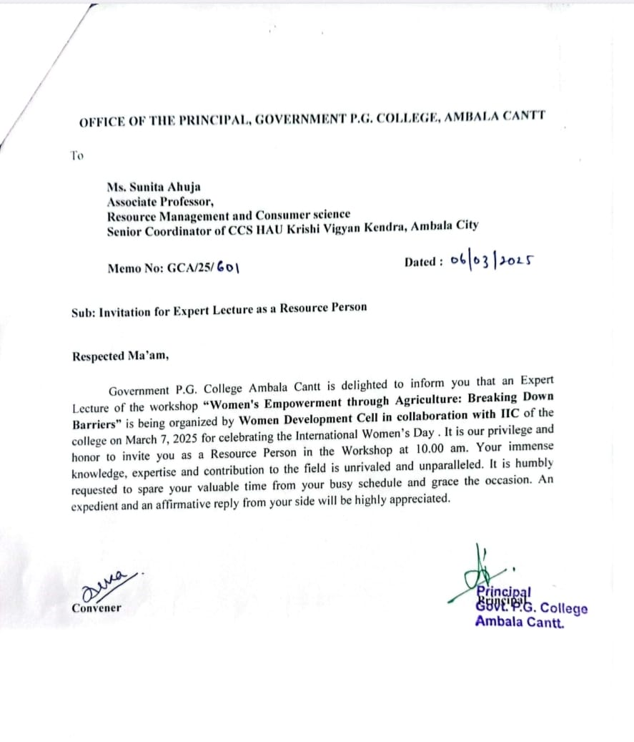



Dr. Des Raj Bajwa

Principal

**Appreciation letter**

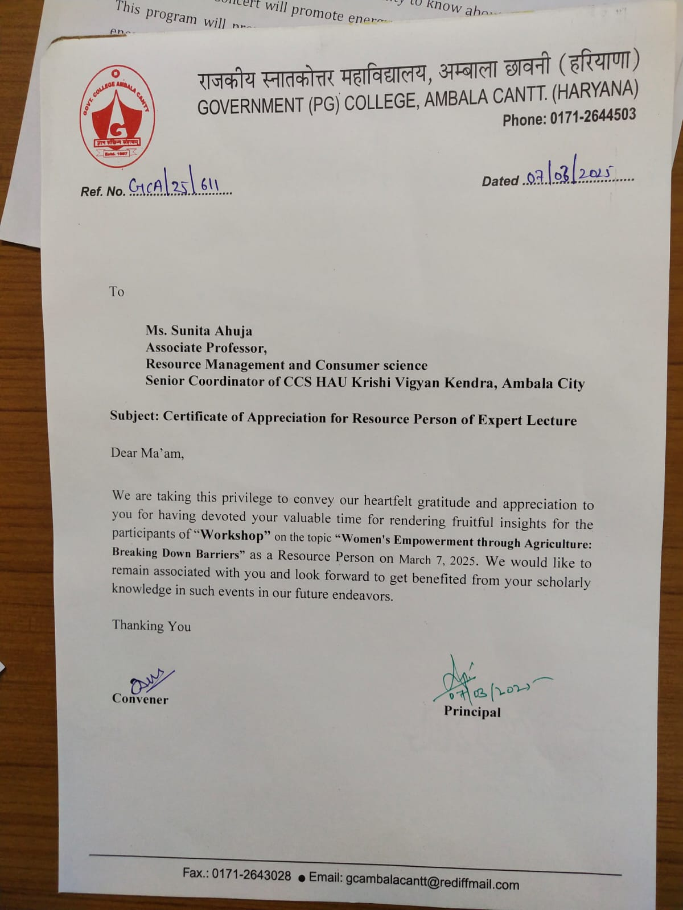



Dr. Des Raj Bajwa

Principal

**Press Note**

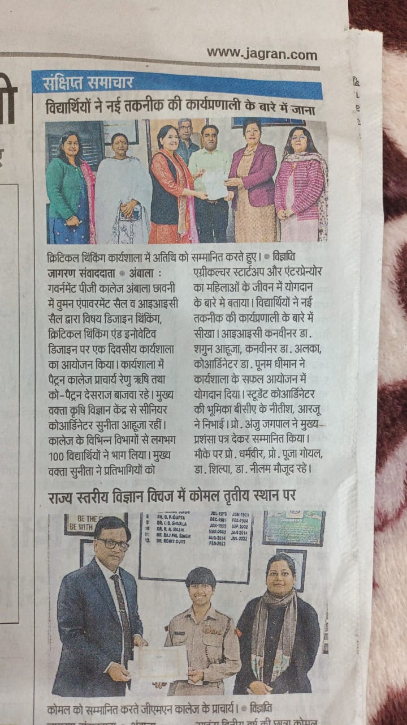



Dr. Des Raj Bajwa

Principal