Permission letter of value added courses from DHE, Panchkula

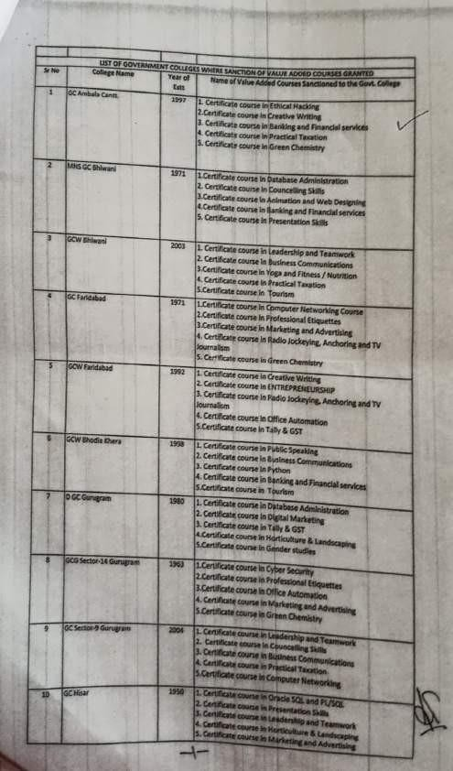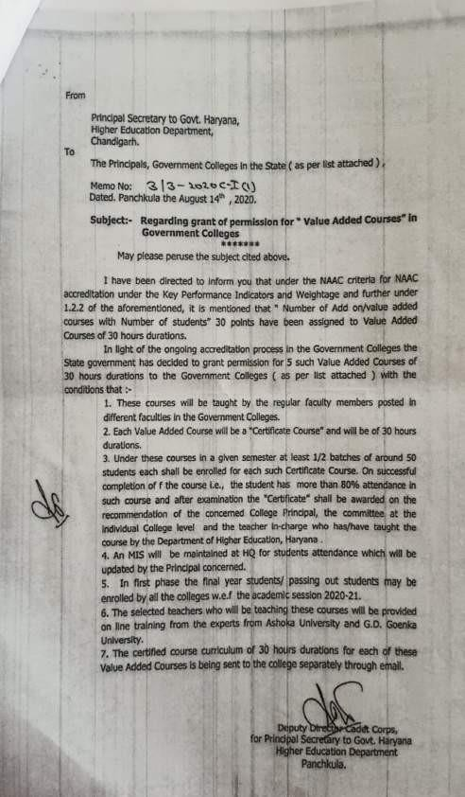

Course notice of value added courses for the session 2023-24

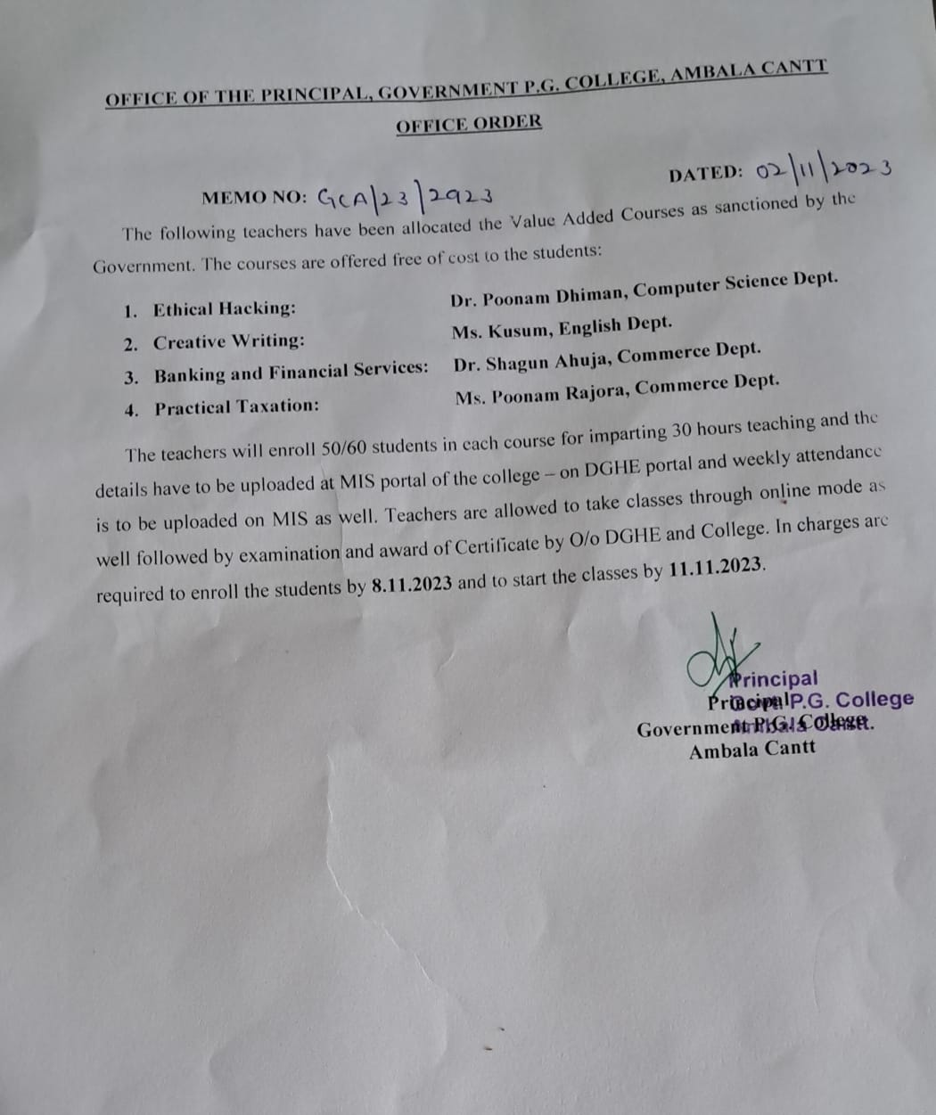

Exam Notice- Certificate Courses

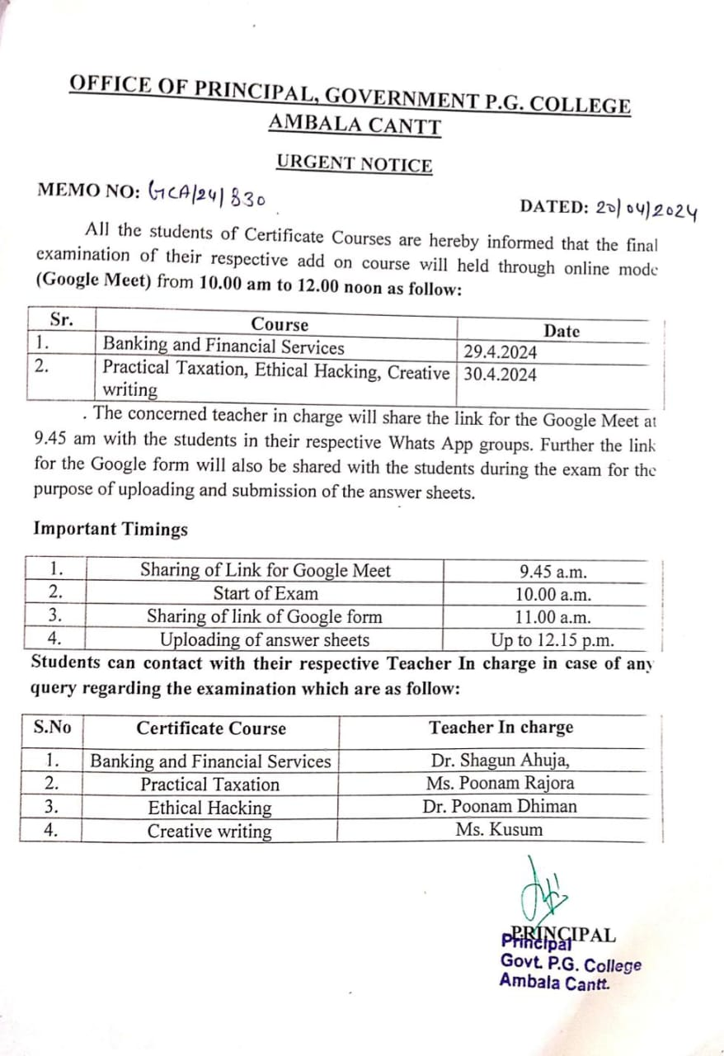

Session 2023-24

|  |  |  |  |  |  |
| --- | --- | --- | --- | --- | --- |
| **Name of Add on/Certificate programs**  **offered** | **Year of offering** | **No. of times offered during the same**  **year** | **Duration**  **of the course** | **Number of students enrolled in the**  **year** | **Number of students completing the course**  **in the year** |
| Ethical  Hacking | 2023-24 | 1 | 30 hours | 41 | 29 |

Syllabus- Ethical Hacking

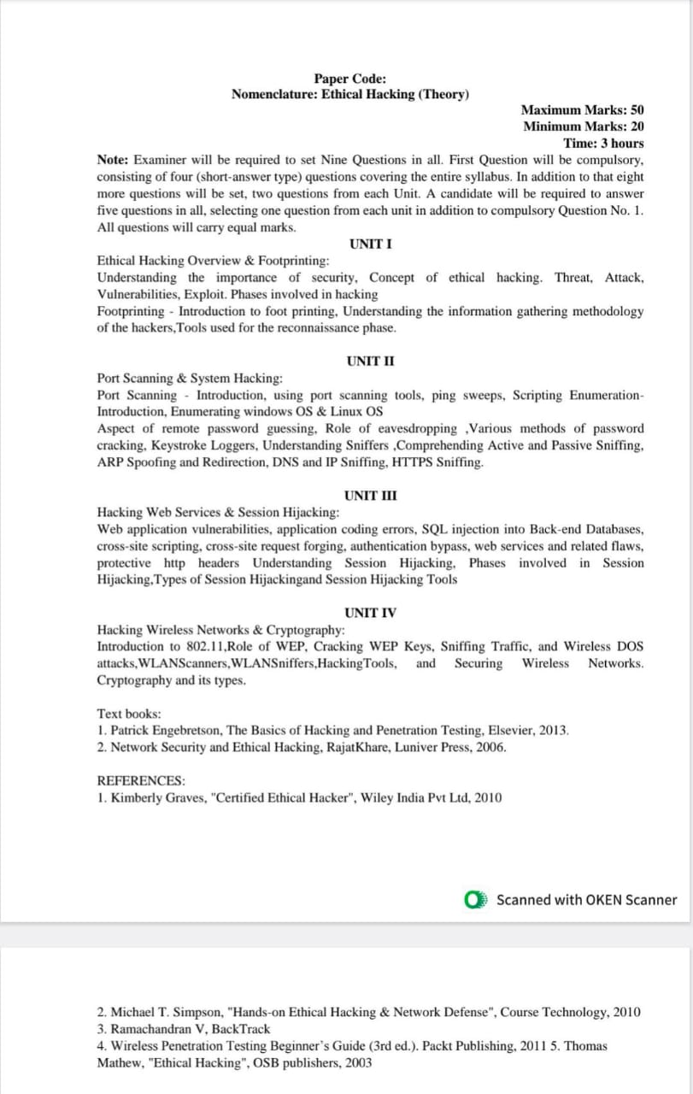

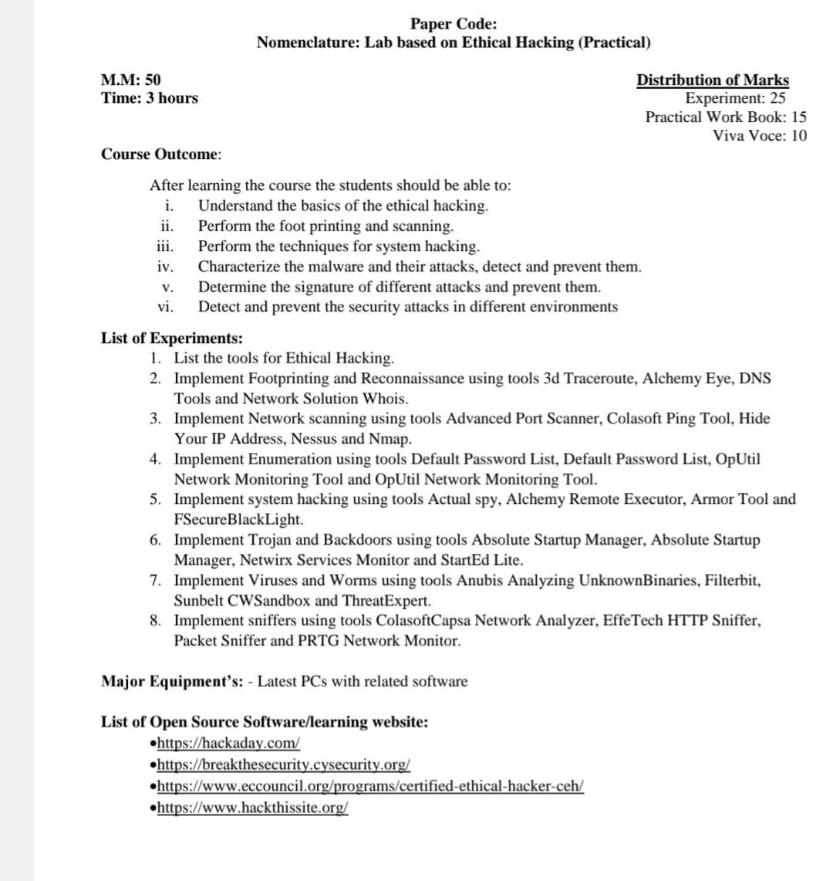

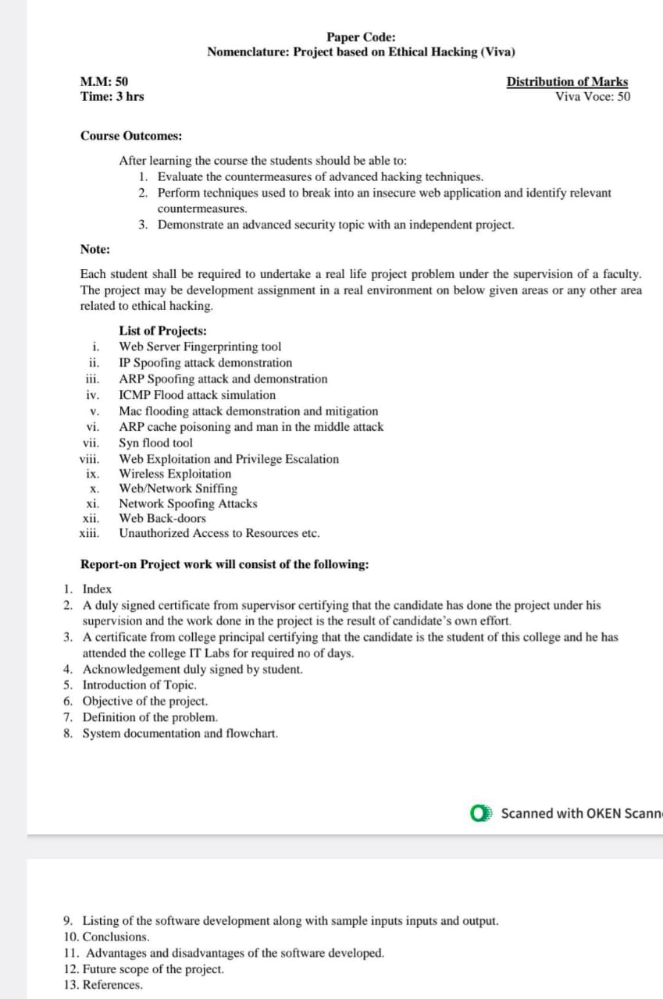

List of students enrolled EthiHacking

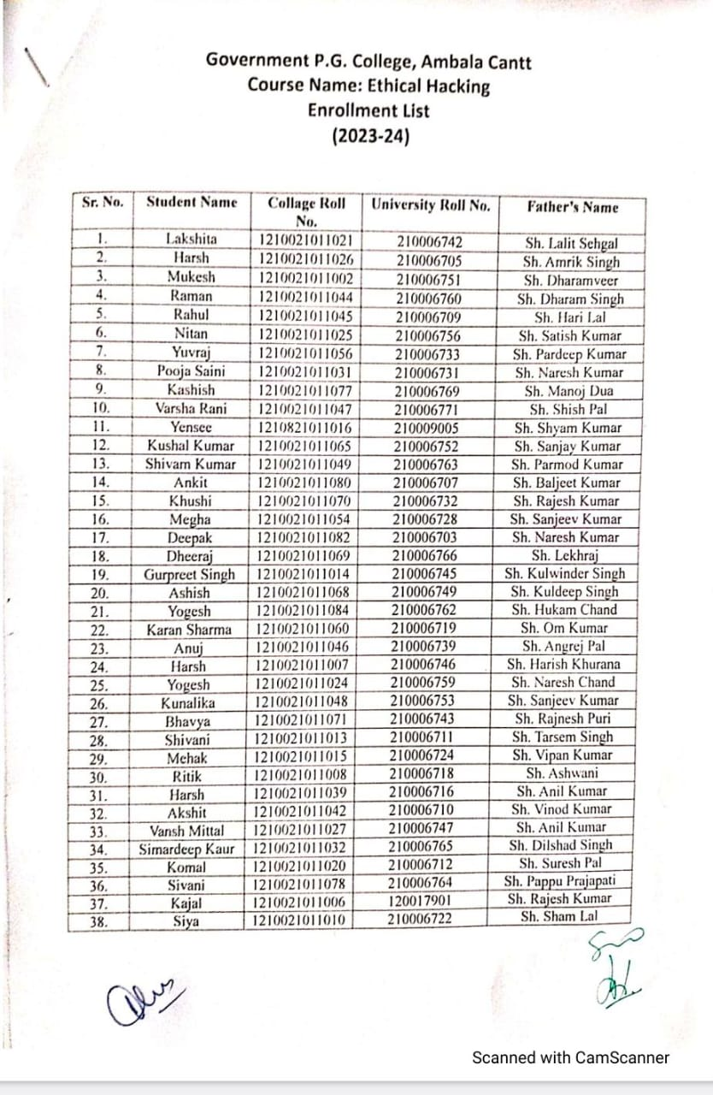

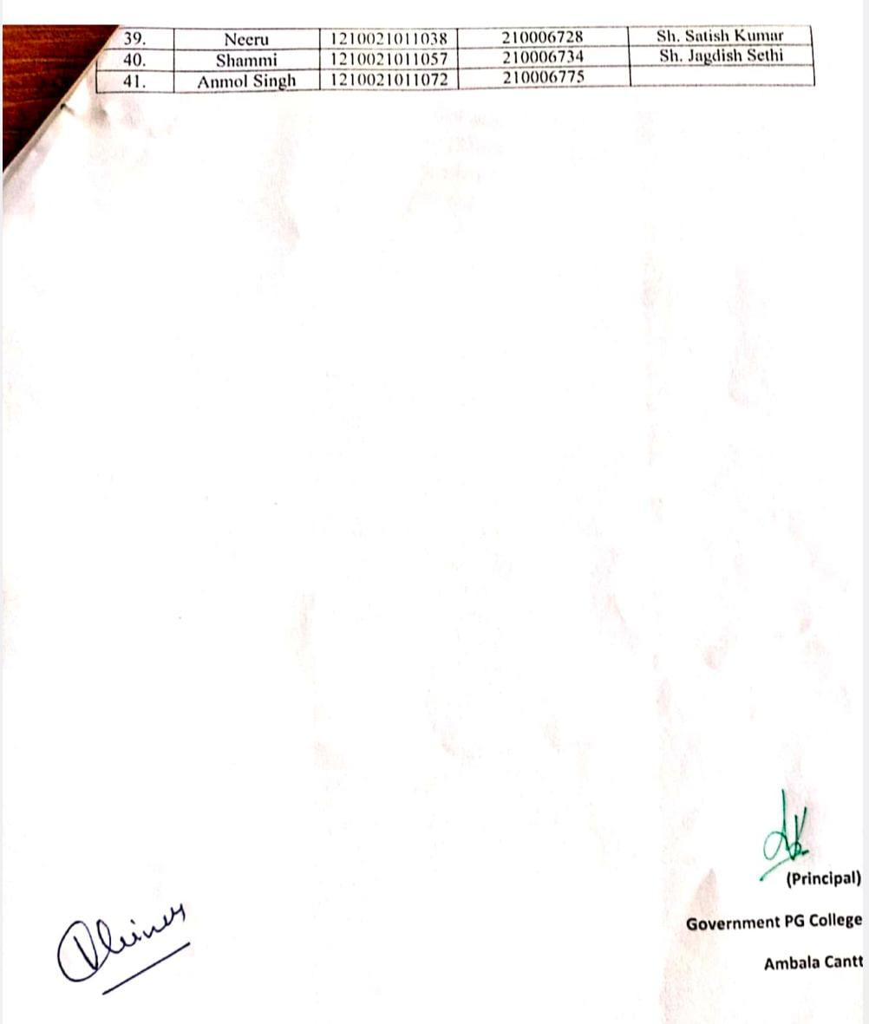

Attendance Record- Ethical Hacking

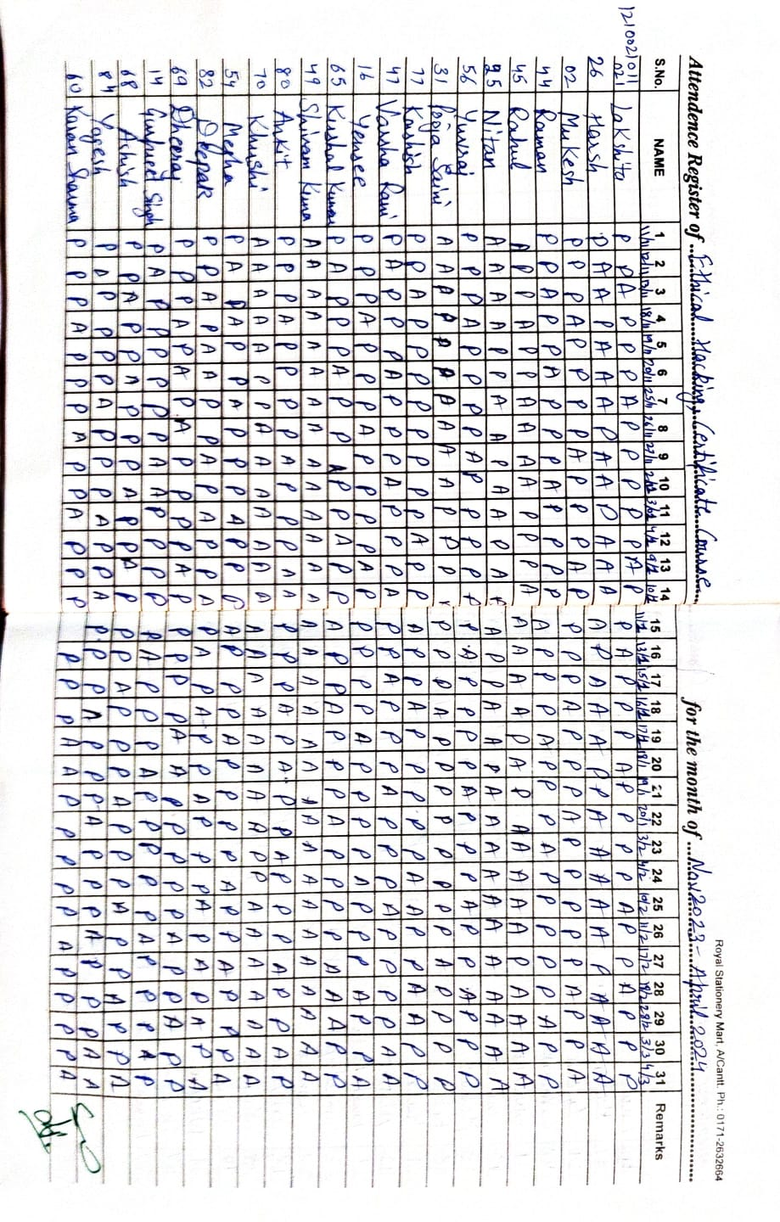

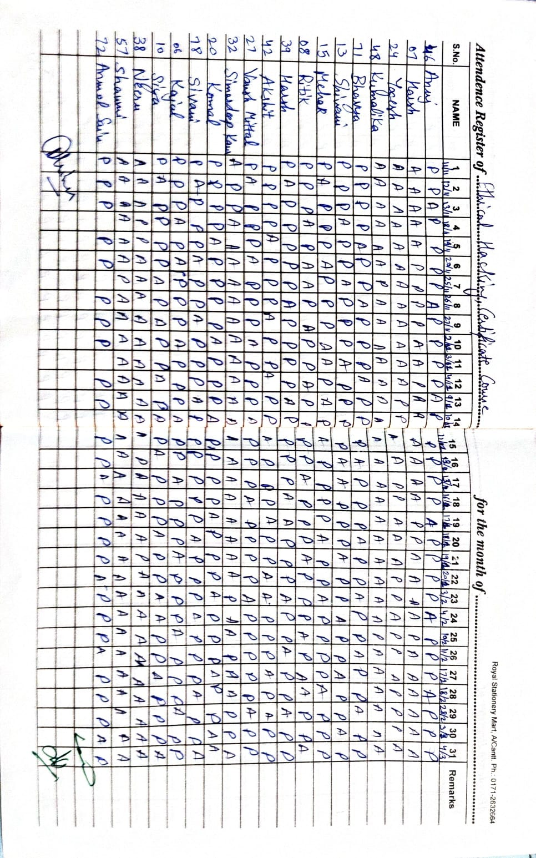

Question Paper- Ethical Hacking

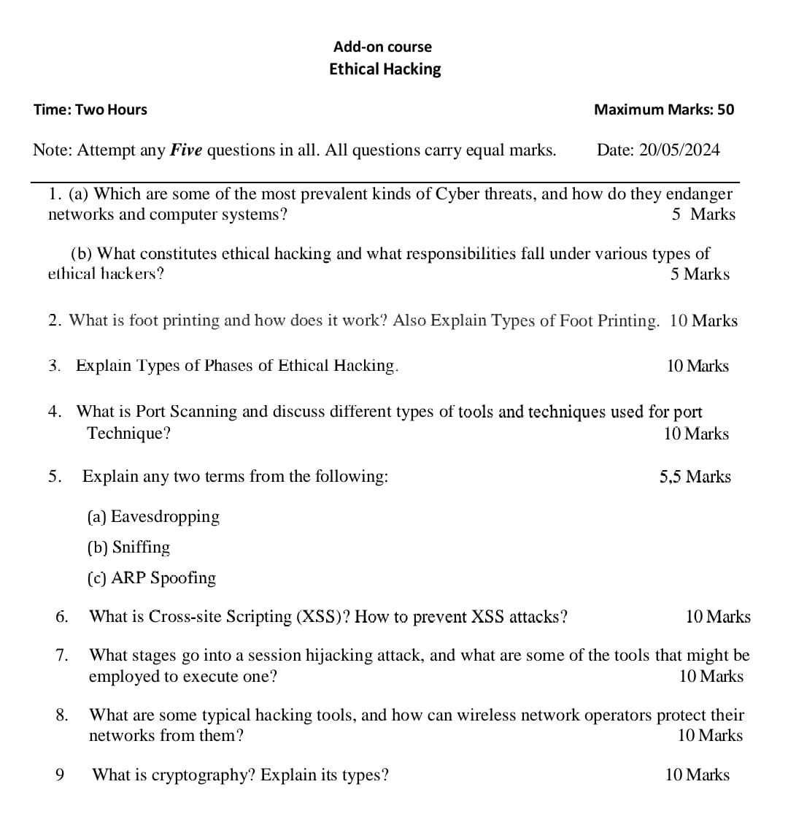

Result – Ethical Hacking 2023-24

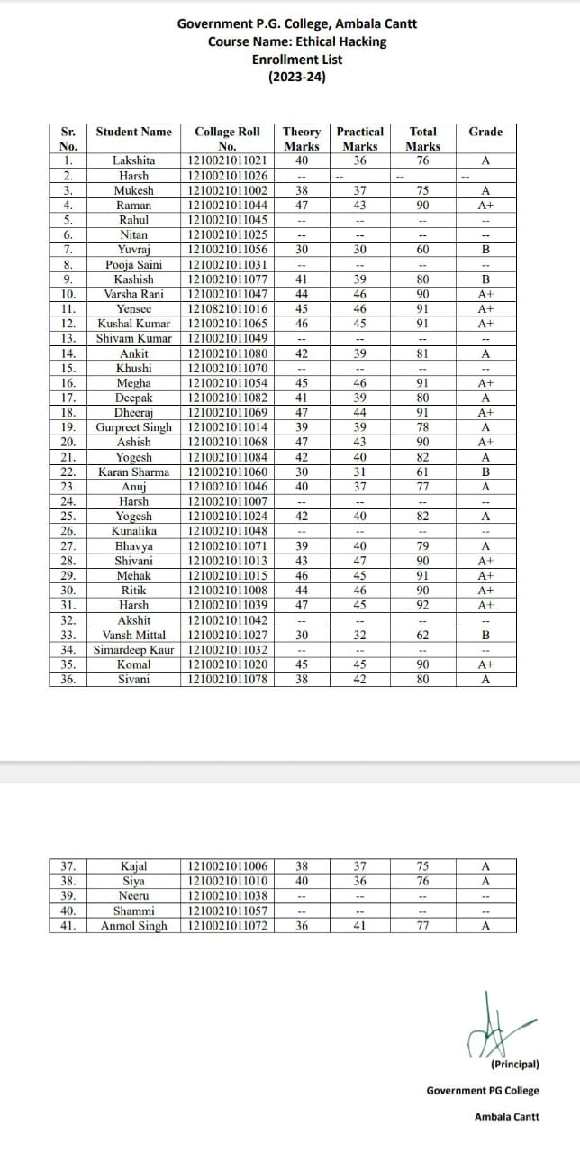

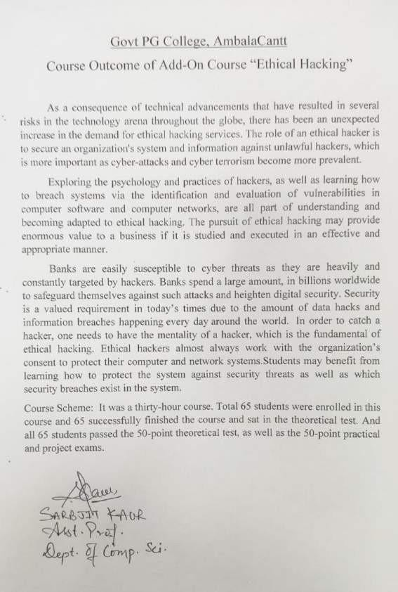

Course Outcome- Ethical Hacking

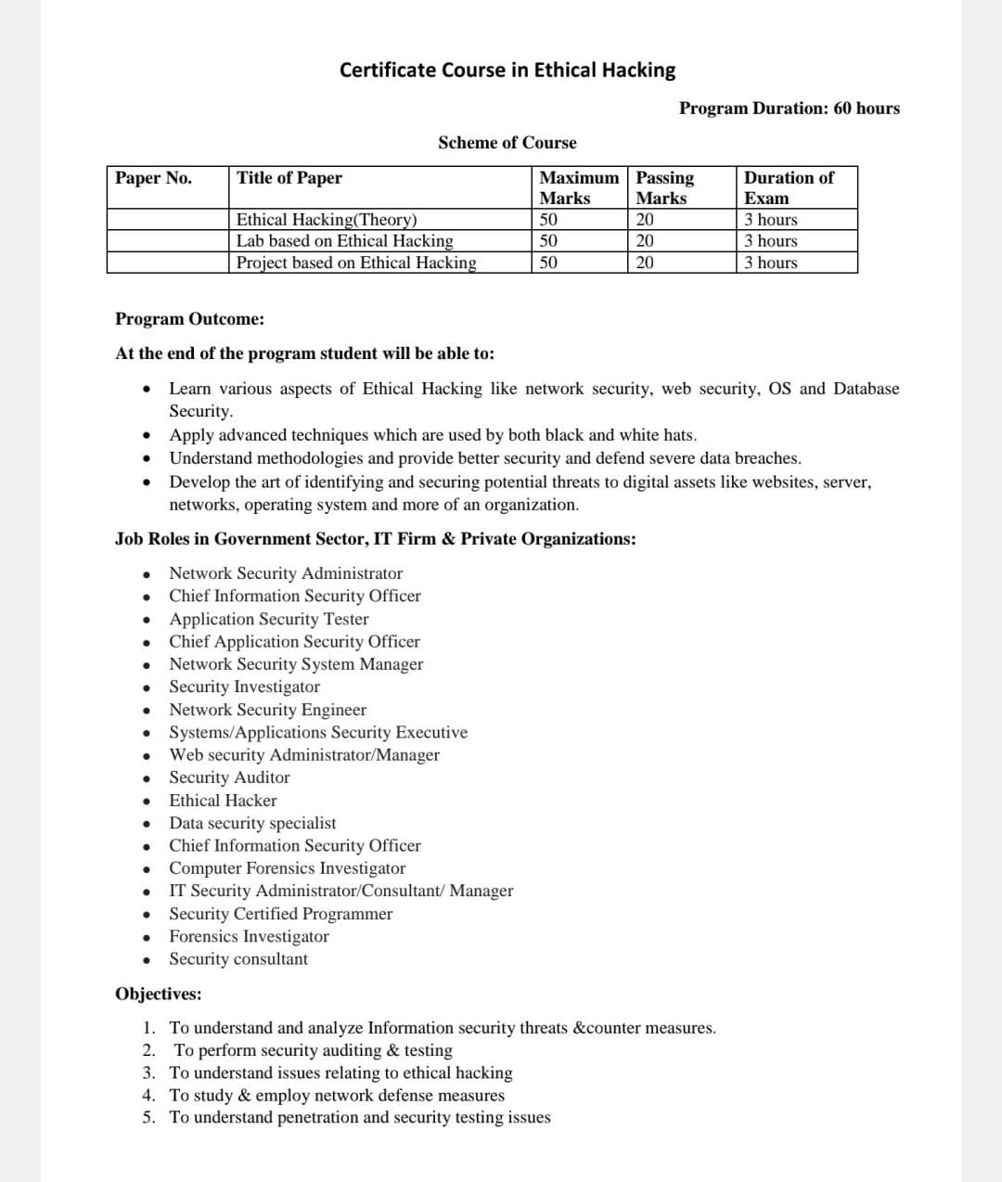

Sample of Certificate given to students after completion of Course

